
Experiment No. 7

Title: Clustering by using fog computing
Aim: Clustering by using fog computing to solve the energy consumption problem.
Theory:
The Internet of Things (IoT) has induced many advances in the modern world, thus always arousing great interest from the scientific community. Due to a large number of connected devices, this paradigm has put into circulation an enormous data quantity to be processed and offloaded while respecting latency and energy constraints that Central Cloud alone cannot meet. Hence, Fog Computing has come to fill these gaps by providing computing, management, and storage resources via small-distributed data centres located at the network edge. The majority of previous research on centralised clustering in an IoT environment did not consider both residual energy and the location of the IoT devices, as well as the signalling communication frequency, to solve an issue of extreme energy consumption during data exchange between IoT devices and Fog entities. Thus, the objective of this study is to find solutions taking into account these criteria to guarantee the Fog system's energy efficiency while coping with the energy consumption increase related to the handling of massive data volume. Indeed, the proposed study presents a novel approach based on Fog-IoT architecture to ensure intelligent energy management during communication and offloaded task processing in IoT applications.
The simulation results show its effectiveness. In order to cope with the explosion in the number of terminals to be served as well as the frantic demand for a constantly increasing speed to convey a massive amount of data in a very short time, several technologies and new computing systems must be developed. Thus, systems based solely on a centralised cloud infrastructure have limitations that may hinder the implementation of certain Internet of Things (iot) applications. Indeed, computing a huge amount of data at the central cloud will have the disadvantage of generating significant latency combined with high storage and bandwidth costs that are detrimental to the proper functioning of delay-sensitive IoT applications.

To this end, the concept of Fog computing has been developed to surmount the latency problems that affect a centralised cloud computing system. It is a decentralised computing infrastructure in which data computing, storage, and applications are sat somewhere between the data source and the central cloud. Concretely, the data is taken care of at two levels; one portion is processed at the fog part while the other portion is transmitted to the central cloud for further processing. This interaction between these two levels makes it possible, among other things, to lighten the burden in terms of bandwidth, storage, and energy consumption . As a result, Fog Computing technology offers users IoT applications that require reduced response time and real-time analysis capabilities such as augmented/virtual reality and online gaming systems .

In an IoT environment, terminals and sensors with energy and coverage limitations are forced to adopt intelligent energy management solutions. So, optimising energy consumption has been the subject of numerous research and innovative approaches aimed at effectively harnessing the benefits of Internet-ofThings applications, including smart homes, smart cities and health care. In this context, clustering techniques and other data routing methods constitute an important asset in order to optimise the collection of information, thereby minimising the energy consumption generated mainly by redundant data transfers by nearby IoT terminals.

Taking into consideration the above-mentioned aspects, this paper presents the following contributions: • The proposed protocol brings a number of improvements to the process of managing the IoT devices related in particular to their residual energies and their positions;

- The proposed protocol also brings improvement to the way data is offloaded to the Fog entities;

- The proposed protocol demonstrates the gain obtained by managing the frequency of communication between the IoT devices and the Fog computing entities.
Fog computing energy minimisation problem
Due to IoT devices' limited amount of resources and networking capability, the operation of clustering the IoT devices layer can significantly save energy and extend the network lifetime while guaranteeing the execution of tasks at the Fog layer. For that matter, designated sensors are upgraded to Small Proxy (SP) servers to aggregate the collected sensed data and send it to FNs for processing/computing capabilities. Only the tasks that cannot be well processed by Fog entities are delivered to the Central Cloud (CC) . Moreover, within the context of Fog Computing architecture, some assumptions have been made as follows:
- • IoT devices are set with the same initial energy, and each device is assigned a unique identification in the network;
- • Once deployed randomly and uniformly, IoT devices are static and their location is known;
- • SP servers perform data collection, data aggregation and data compression; 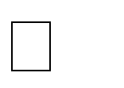 • Fog Nodes perform cloud computing tasks (computing and storage) and IoT network management;

- • The distance between the IoT device and the SP server can be measured based on the radio signal strength;
- • The IoT devices are all time synchronised and begin the first phase at the same time. This could be realised, for instance, by having the Fog Node sends out synchronisation pulses to all devices.
Currently, a large amount of research is aimed at modelling low-energy radios and transmission power as a function of the distance between the source node and the destination node. The radio communication model adopted in the LEACH-C protocol is used to model the energy dissipation in this paper. This model can be divided into a free space model and a multi-path fading model according to the distance between the sending device and receiving device

Procedure:
Step 1]



Step 2]
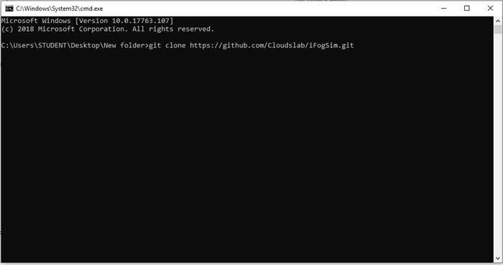
Step 3]

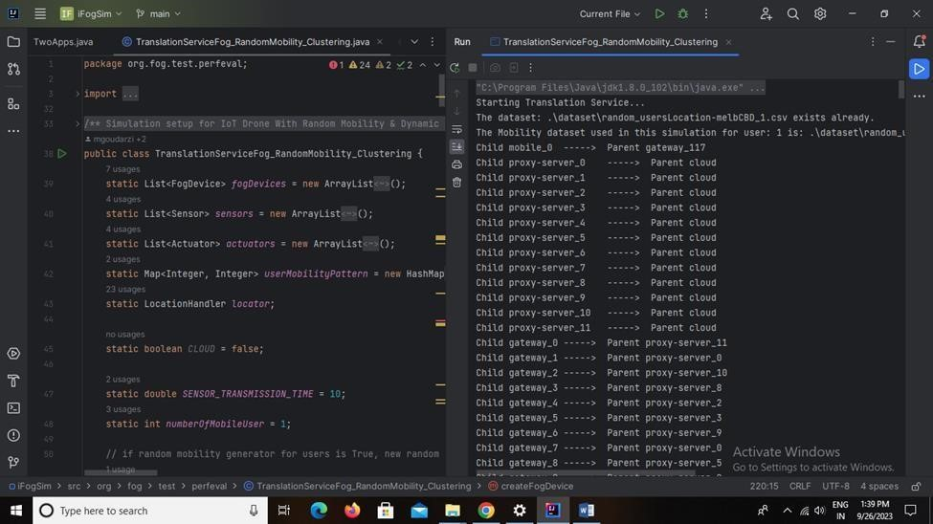

Result:

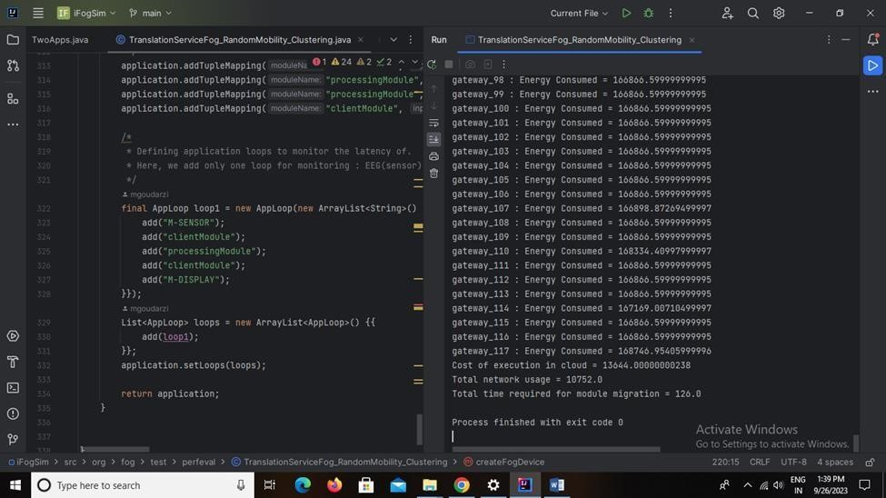

Conclusion:
Hence, we have successfully done with Clustering by using fog computing to solve the energy consumption problem. We solve this problem without any error.

